Getting Started Guide

Welcome to a better way to work

Getting started with Citrix Workspace for macOS
Your new workspace is the easiest way to get work done across all your devices, from wherever you are. To get started, simply download Citrix Workspace app for instant, secure access to all your apps, desktops, and files.

What’s inside
How to install Citrix Workspace app How to access your apps
How to access your desktops How to access your files
How to access your workspace on your mobile device
3

5

6

6

7

How to install Citrix Workspace app

Steps 1 & 2 Step 5
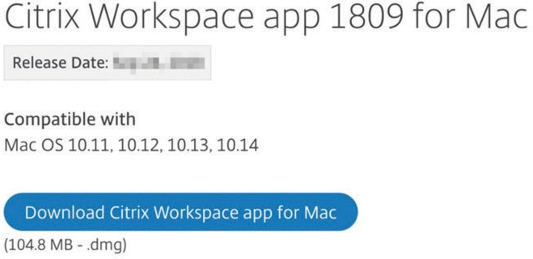

Open your web browser, and navigate to
www.citrix.com/workspaceapp.

Click Download Citrix Workspace app for Mac.

Step 3

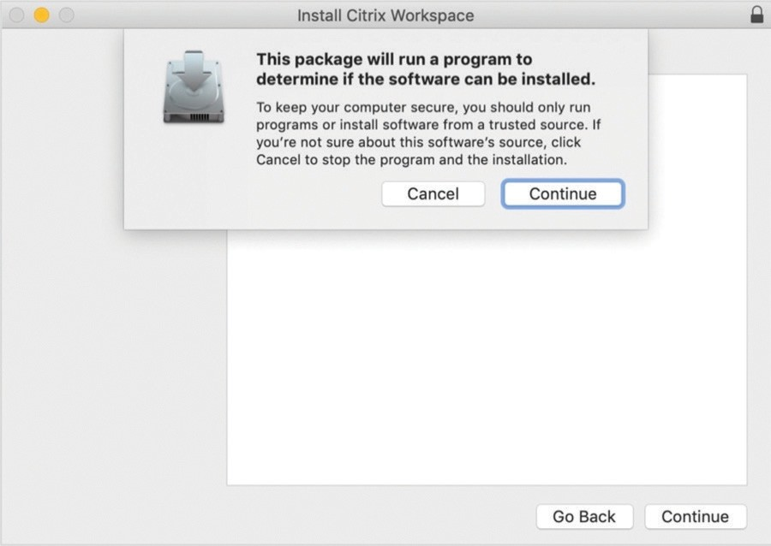When prompted, click Continue.

Step 6

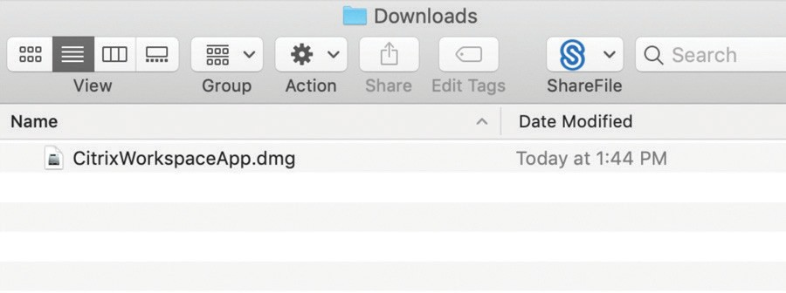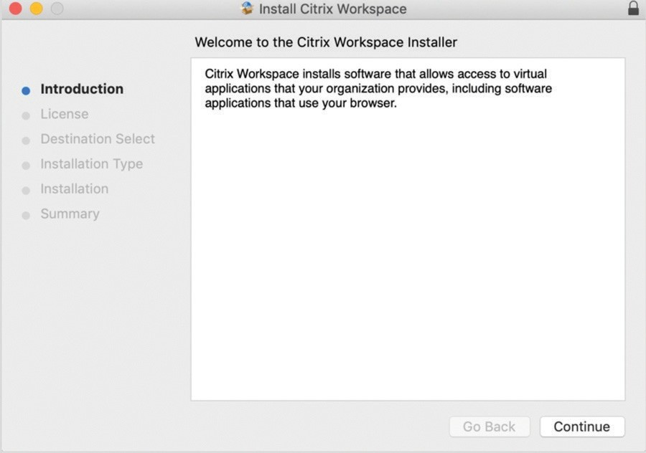Navigate to the default location files are set to download for your Mac, and double-click CitrixWorkspaceApp.dmg.

Step 4

Click Continue to run the Welcome to the Citrix Workspace In0staller.

Step 7

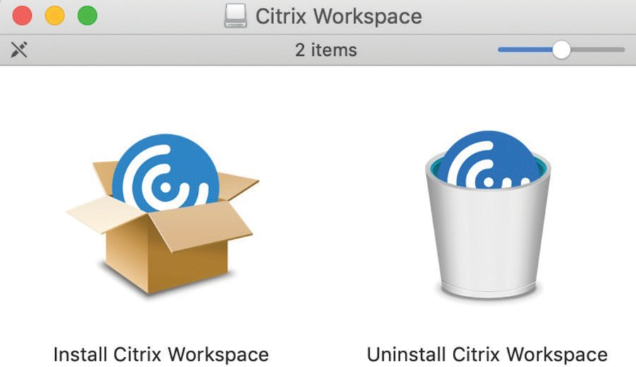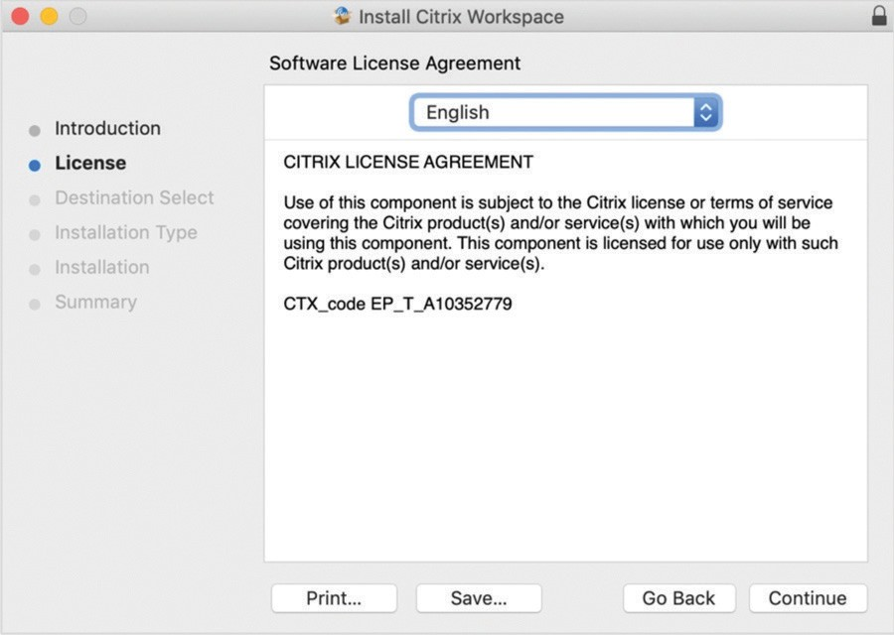Double-click Install Citrix Workspace.

Click Continue.

Step 8 Step 11
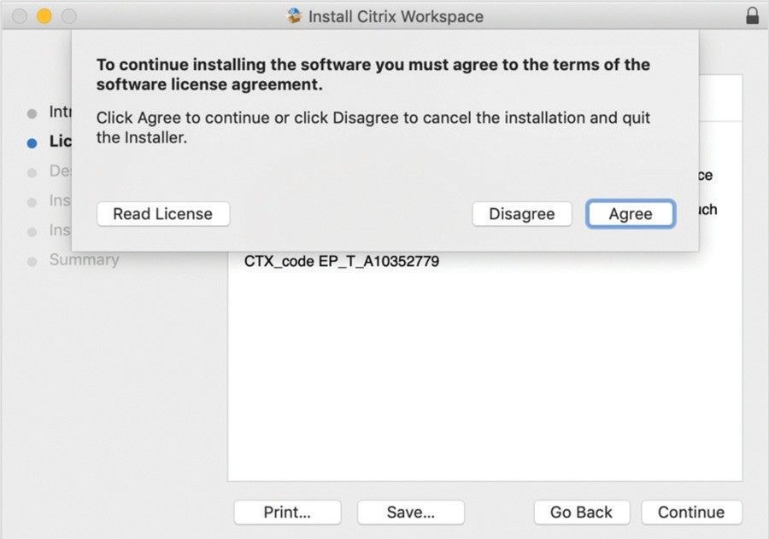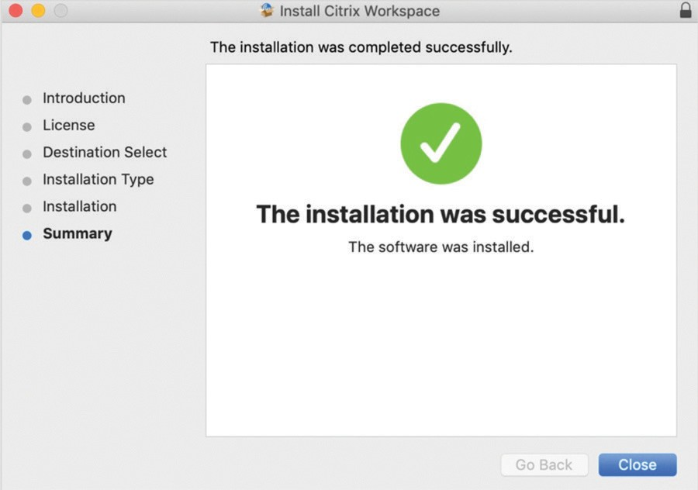

Click Agree to continue.

Step 9
Click Close.

Step 12

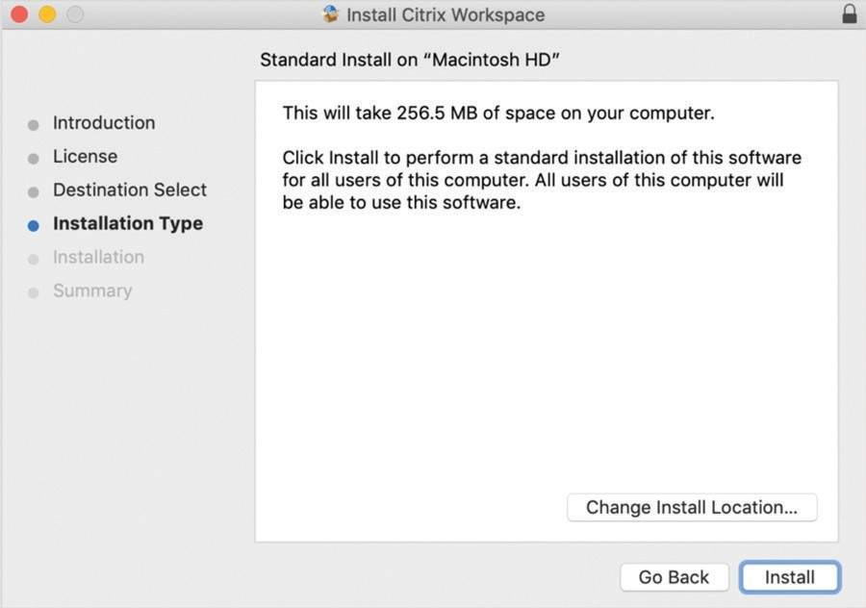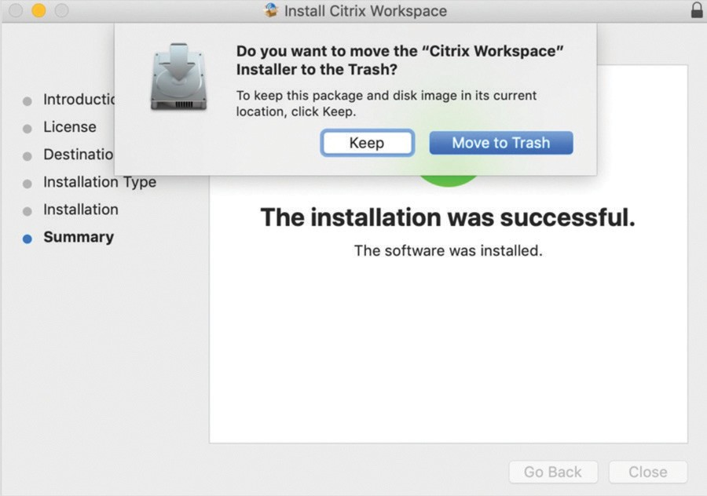

Click Install.

Note: Only change the install location if specified by your organization’s Citrix administrator.

Step 10
Click Move to Trash when prompted.

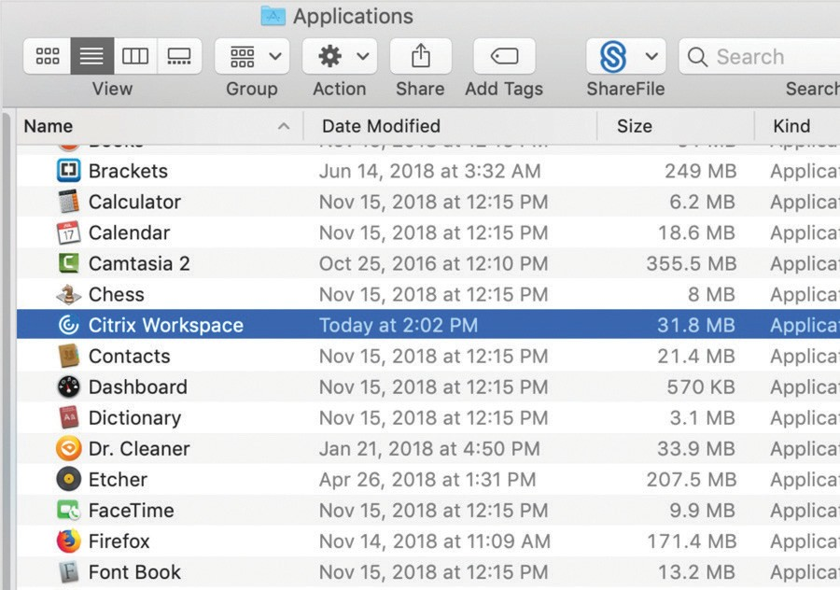Step 13

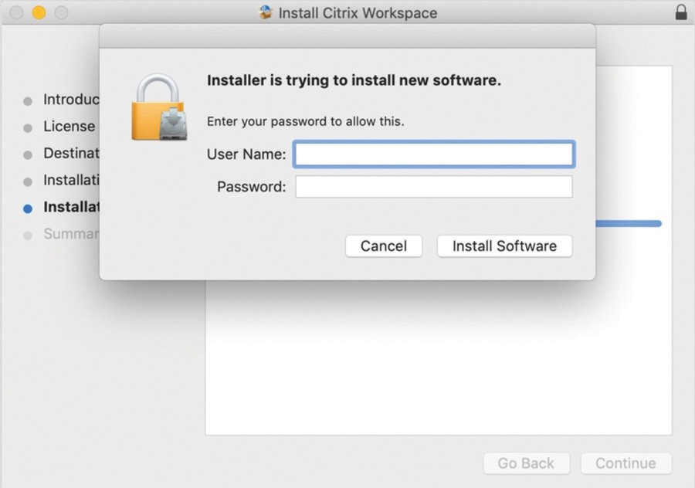If your Mac is set with a user name and password, enter your device’s credentials, and click Install Software.
Navigate to Applications, and double-click
Citrix Workspace to launch the app. You can also use Spotlight Search by pressing Command + spacebar and typing “Citrix Workspace”.

Step 14 Step 15

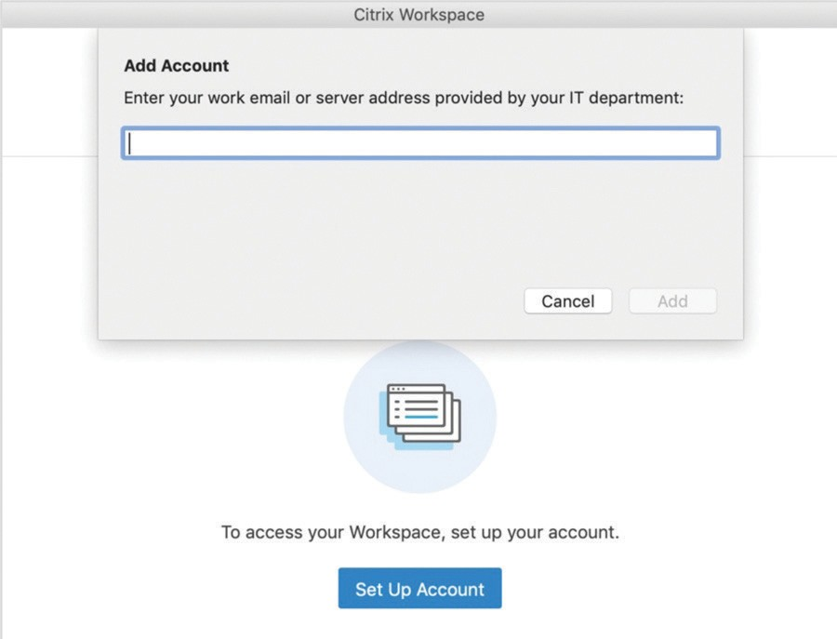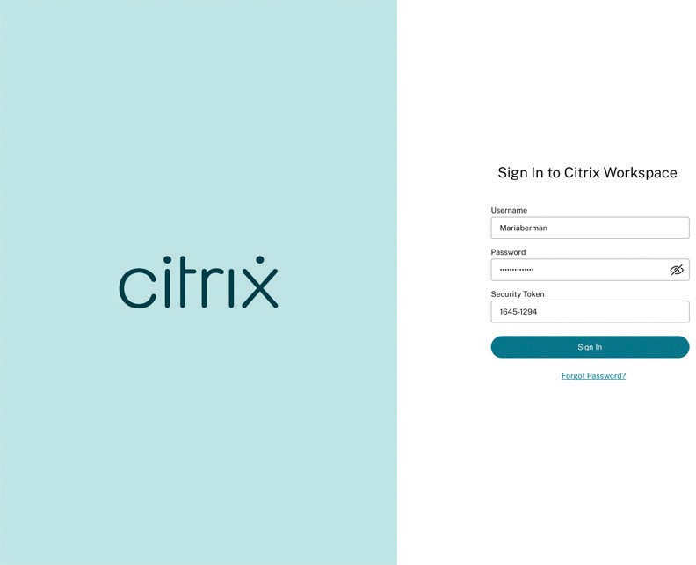

To add your account, enter your workspace URL, and click Add. You can get your workspace URL from your company’s Citrix administrator.
Note: Some users may be prompted, “Do you want to use the information provided by ‘(your company)’ to configure your account?” If prompted, click Continue.
Enter your corporate user name and password, and click Log On.

How to access your apps

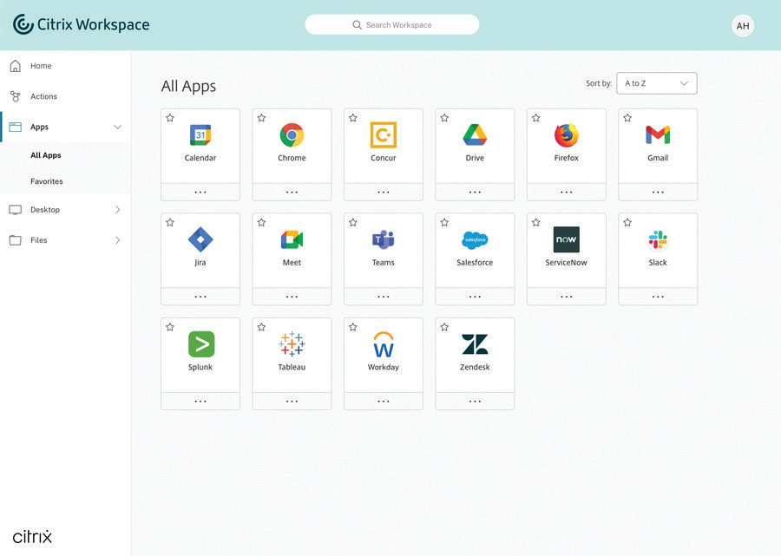Step 1

Step 2
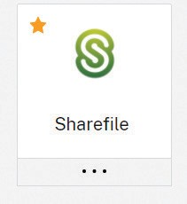
To “Favorite” an app, select the star. Then, click on the application card to open it and access the app.

From the Home screen, click on the Apps tab on the left navigation bar. From there, you can choose All Apps or Favorites.

How to access your desktops

Step 1

Step 2

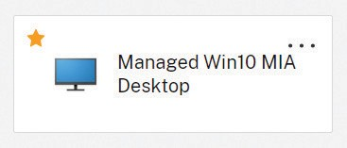

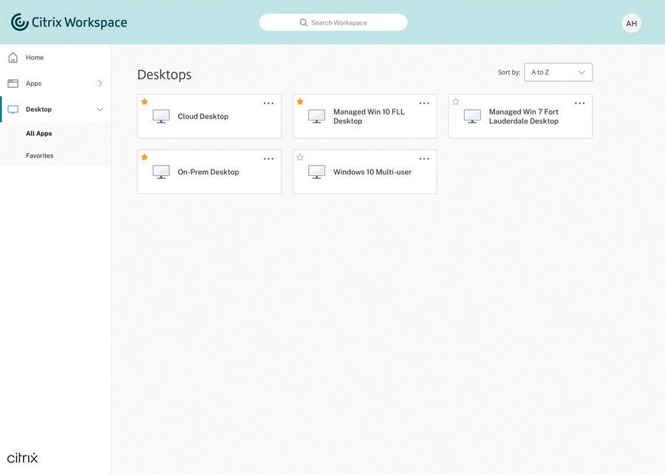To “Favorite” a desktop, select the star. Then, click on the desktop card to open it and access the desktop

From the Home screen, click on the Desktops tab
on the left navigation bar. From there, you can choose
All Desktops or Favorites.

How to access your files

Step 1

Step 2

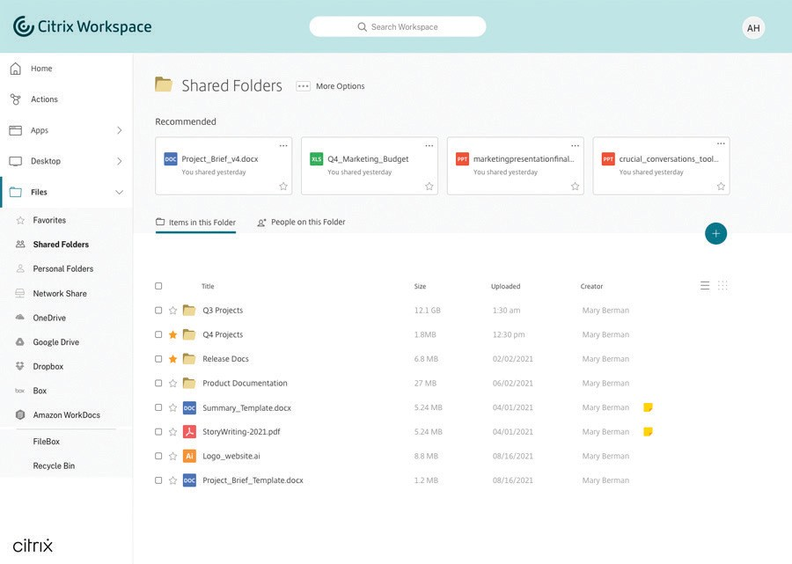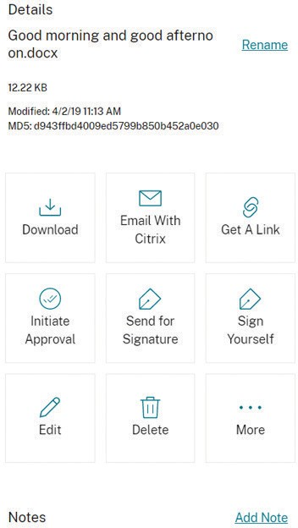

From the Home screen, click on the Files tab on the left navigation bar. From there, you will have access
When you access a file, you’ll be able to perform the following actions:

to all your files, no matter where they are stored.
- Download
- Email
- Get a link
- Initiate approval
- Delete
- Copy
- Move
- Add notes

How to access your workspace on your mobile device

Step 1
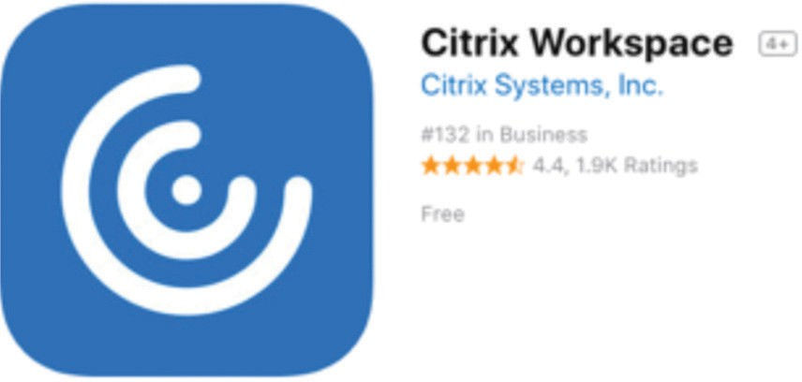
To download Citrix Workspace app on your mobile device, visit the App Store or Google Play, search for “Citrix Workspace app.” Once you download the app, sign in with your corporate credentials.

Step 2
Step 3
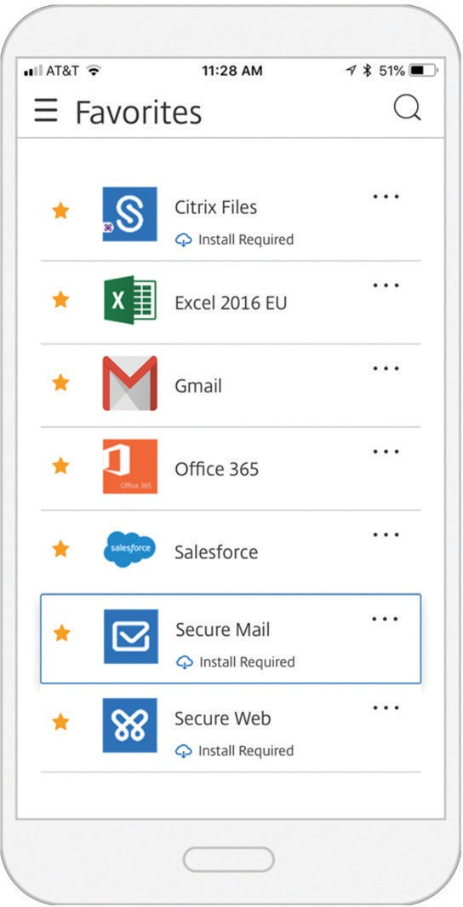
On your mobile device, you have access to secure productivity apps, like Secure Mail. For more on how to use Secure Mail, read the user guides.

Enterprise Sales
North America | 800-424-8749 Worldwide | +1 408-790-8000
Locations
Corporate Headquarters | 851 Cypress Creek Road, Fort Lauderdale, FL 33309, United States Silicon Valley | 4988 Great America Parkway, Santa Clara, CA 95054, United States
©2021 Citrix Systems, Inc. All rights reserved. Citrix, the Citrix logo, and other marks appearing herein are property of Citrix Systems, Inc. and/or one or more of its subsidiaries, and may be registered with the U.S. Patent and Trademark Office and in other countries. All other marks are the property of their respective owner(s).

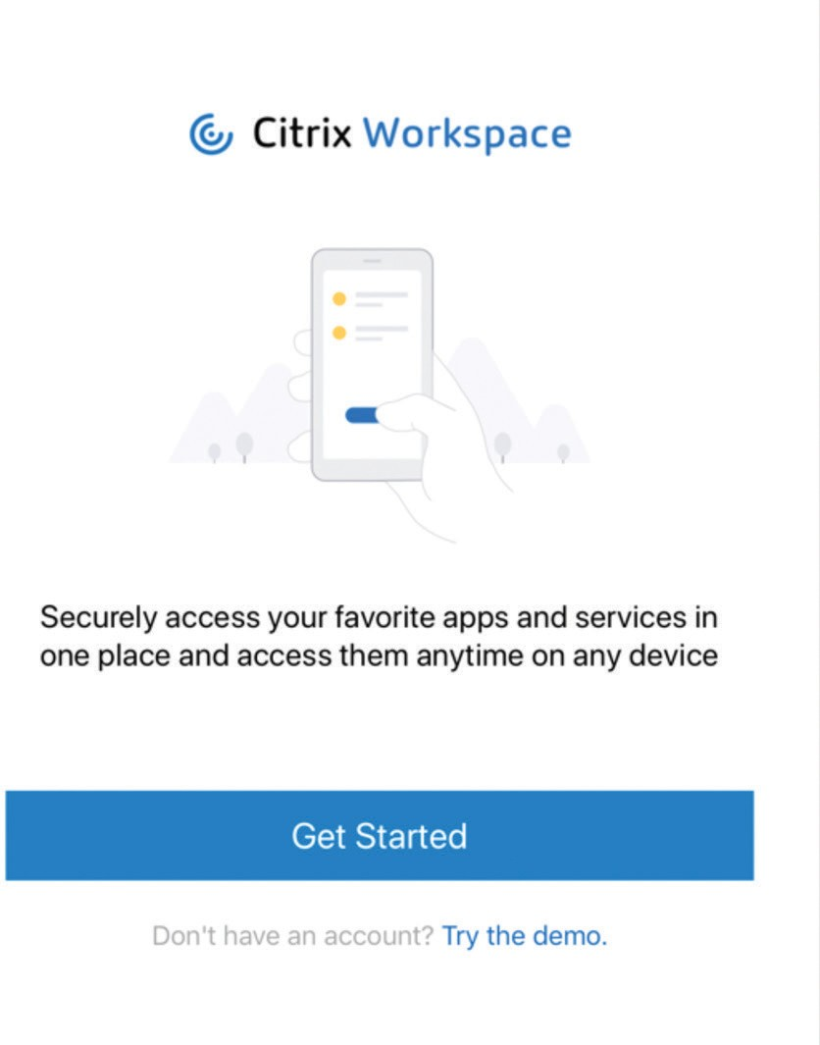Citrix Workspace app will prompt you to then download
Citrix Secure Hub for authentication purposes.

