Getting Started Guide

Welcome to a better way to work
Getting started with ShareFile
Welcome to the simple, secure way to share files on any device, anywhere. ShareFile is a simple, secure way to collaborate on your files with colleagues and customers. You can easily store, share, sync, and access your files from any device, no matter where you are. This guide shows you how to use ShareFile to become more productive than ever. See how easy it is to get started.

What’s inside
How do I sign in to ShareFile How do I upload a file?
How do I share a file?

How do I send a file through Microsoft Outlook?

How do I send a file through Gmail or other accounts? How do I send an encrypted email?
What file types can I upload?
How do I request a file from a coworker or client? Still need help?
3

3

3

5

5

5

5

5

6

How do I sign into ShareFile?
To sign in, go to [subdomain.sharefile.com], and enter your user name and password.
If your organization has configured single sign-on, you’ll be able to sign in with your company credentials from this same screen.

How do I upload a file?
It’s easy to upload files to ShareFile, whether you’re using a web browser, a ShareFile tool, or your mobile device.
- Web browser: Navigate to the folder where you’d like to upload a file. Click the + button, select Upload, and either drag and drop a file right into ShareFile or browse your computer.
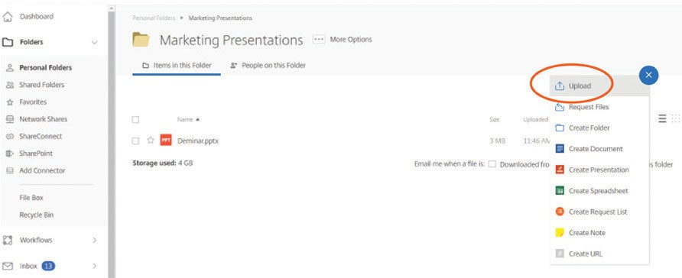

- Drive Mapper is now Citrix Files for Windows and Citrix Files for Mac: Go to www.citrix.com/downloads/ sharefile to download this tool. Once downloaded, simply map to a drive and then save your file and it is automatically synced from the cloud to your desktop.
- Mobile app: If you’re accessing ShareFile through your mobile app, navigate to the folder where you’d like to upload the file, click the + button, select Upload, and browse to find the file you want to upload.
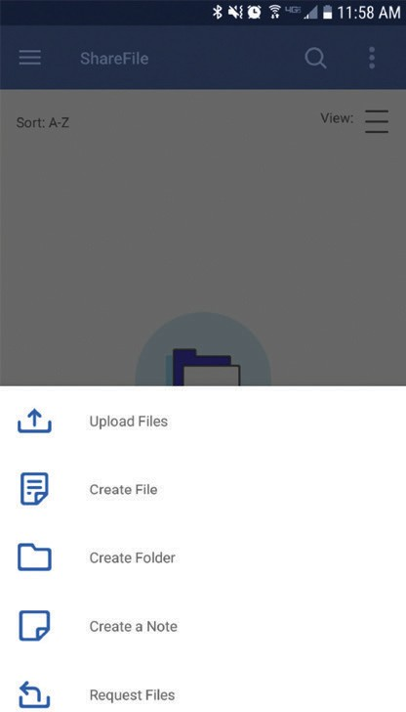

How do I share a file?
There are several ways to share a file.

- Email with ShareFile: This feature allows you to send your file(s) via ShareFile’s email system. With this method, the recipient receives an email message
containing a secure link to download the file(s). You can send a file stored on your account, or send a file stored on your computer.
A. To email a file stored on your account: Right-click on the file in ShareFile, choose the Share option, then select Email with ShareFile.

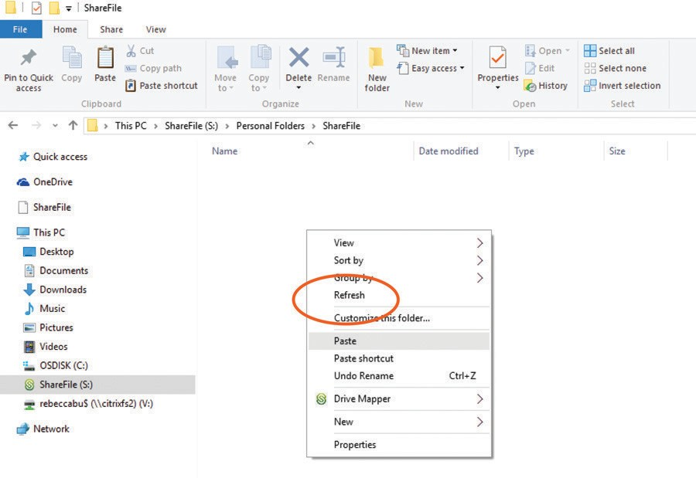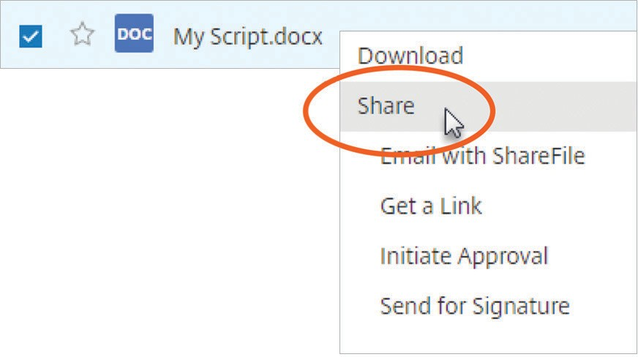

B: To email a file stored on your computer: Go to your ShareFile dashboard shortcuts, choose Share Files, then select Email with ShareFile.
  - To get a link for a file stored on your account: Right-click on the document, and select Share and then Get a Link. Copy and paste the link and share.

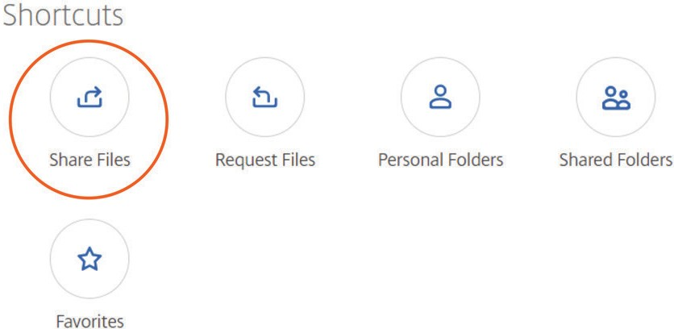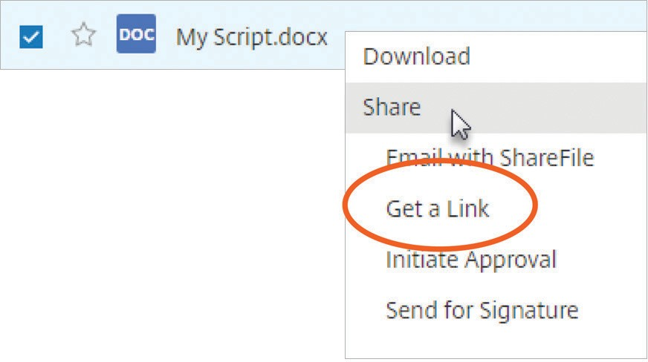

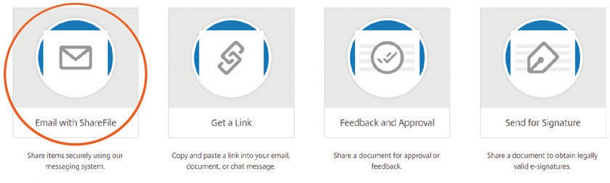What your recipient sees:
  - To get a link for a file stored on your computer: Go to your ShareFile dashboard shortcuts, choose Share Files, and then select Get a Link. Copy and paste the link, and share.

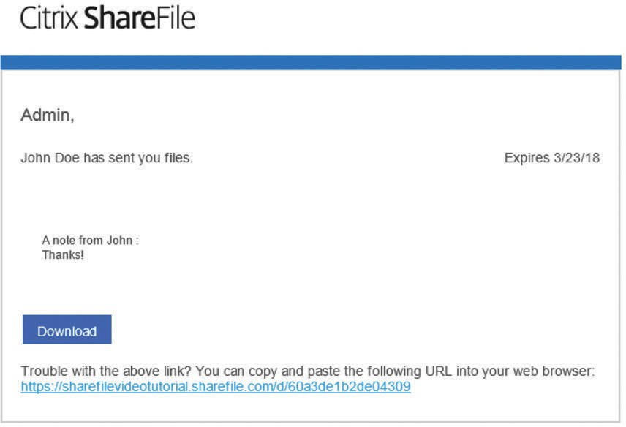

- 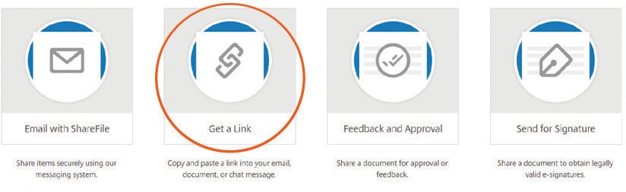Get a Link: This feature creates a link you can
copy and paste into any email or chat message to allow a recipient to safely access your file. You can share a file stored on your account, or share a file stored on your computer.

How do I send a file through Microsoft Outlook?
Once you download Citrix Files for Outlook (www.citrix.com/downloads/sharefile), simply open a new email message, you’ll see some ShareFile options in the message ribbon. You have two options for adding a file to your message:
- Convert Attachments will turn any files you’ve already attached to the email into secure ShareFile documents.
- Attach Files allows you to use ShareFile to attach documents that are either saved in your
ShareFile account or stored locally on your computer.
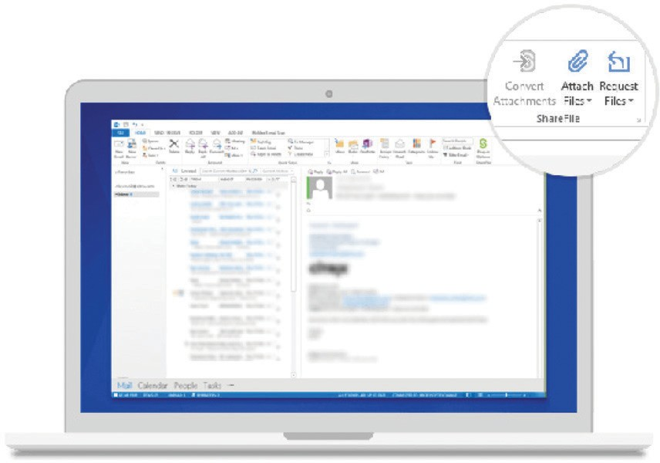

How do I send a file through Gmail or other accounts?
The easiest way to send a file through any email program is to use the “Get a Link” function within ShareFile from your browser. Copy and paste the ShareFile link into your Gmail message for a quick, safe way to share your file.

How do I send an encrypted email?
When you open a new email message in Outlook, you’ll see a green ShareFile padlock icon on the left of the message ribbon. Click the drop-down arrow and then Use Custom Settings. After confirming a few options, your entire message text will be encrypted—both on its way to your recipient and once it’s in their inbox.
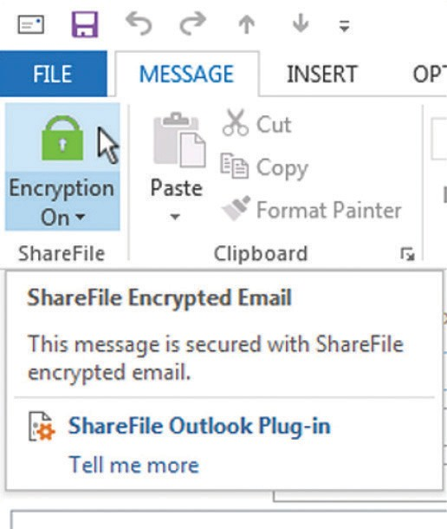

What file types can I upload?
ShareFile supports all file types.

How do I request a file from a coworker or client?
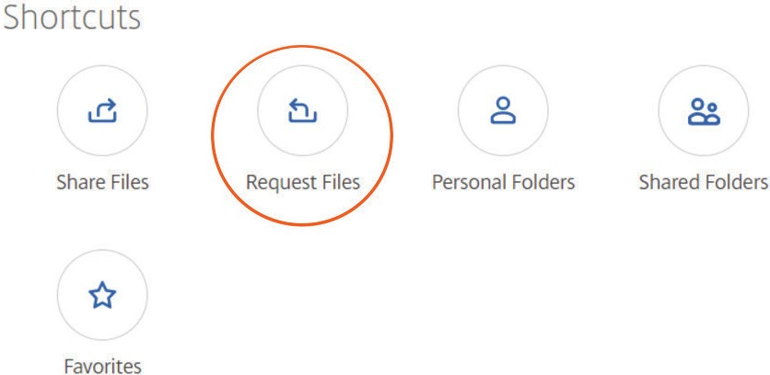There are two ways to easily request a file from someone. On your account dashboard, click Request Files.

- Request with ShareFile: Choose this option to send a request through ShareFile. Fill out the fields for
recipients and message, check the location where you’d like files uploaded, and click Send.
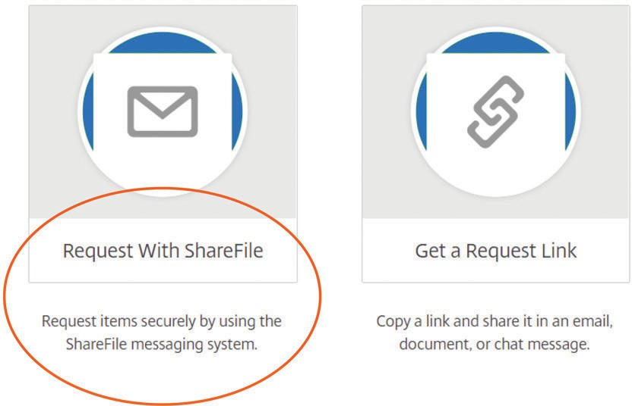

- Get a link: Choose this option to request a link to embed in an email, chat, or site. Verify the location where you’d like files uploaded, and click Get a Link.
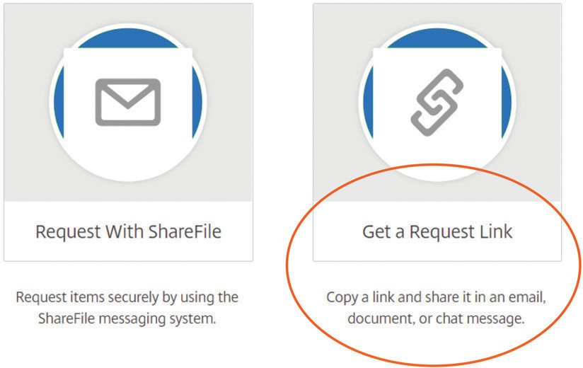

A. You can place this link right in your email signature from Outlook. Open a new email, and click the Insert tab. You’ll see an icon for Signature. Open the drop- down arrow, and click Signatures... In the Edit Signature box, you can place the link wherever you’d like in your email signature. Save it, and it’s ready to send.

Still need help?
Here are some additional resources:

- Access hundreds of support articles in the
ShareFile Knowledge Center
- Connect with other customers in the ShareFile Community and see commonly asked questions

Enterprise Sales
North America | 800-424-8749 Worldwide | +1 408-790-8000
Locations
Corporate Headquarters | 851 Cypress Creek Road, Fort Lauderdale, FL 33309, United States Silicon Valley | 4988 Great America Parkway, Santa Clara, CA 95054, United States
©2021 Citrix Systems, Inc. All rights reserved. Citrix, the Citrix logo, and other marks appearing herein are property of Citrix Systems, Inc. and/or one or more of its subsidiaries, and may be registered with the U.S. Patent and Trademark Office and in other countries. All other marks are the property of their respective owner(s).

