Getting Started Guide

Welcome to a better way to work
Getting started with Citrix Content Collaboration
Welcome to the simple, secure way to share files on any device, anywhere.
Content Collaboration is a simple, secure way to collaborate on your files with colleagues and customers. You can easily store, share, sync, and access your files from any device, no matter where you are, all within Citrix Workspace. This guide shows you how to use Content Collaboration to become more productive than ever. See how easy it is to get started.

What’s inside
How do I sign in to Content Collaboration How do I upload a file?
How do I share a file?

How do I send a file through Microsoft Outlook?

How do I send a file through Gmail or other accounts? How do I send an encrypted email?
What file types can I upload?
How do I request a file from a coworker or client? Still need help?
3

3

4

5

5

5

5

6

6

How do I sign into Content Collaboration?
Content Collaboration features are part of Citrix Workspace. Access your files from connected content sources in one place via the left navigation.
- Web browser: To sign in, go to [subdomain.cloud.com], and enter your user name and password.
If your organization has configured single sign-on, you’ll be able to sign in with your company credentials from this same screen.
- Citrix Workspace app:

How do I upload a file?
It’s easy to upload files to Content Collaboration, whether you’re using a web browser, the Citrix Workspace app, or your mobile device.
- Web browser: Navigate to the folder where you’d
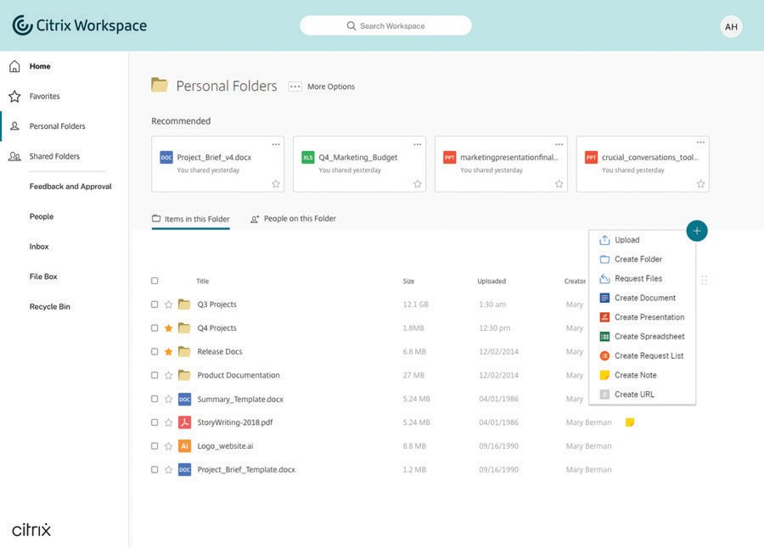like to upload a file. Click the + ... button, select Upload, and either drag and drop a file right into the window or browse your computer.

- 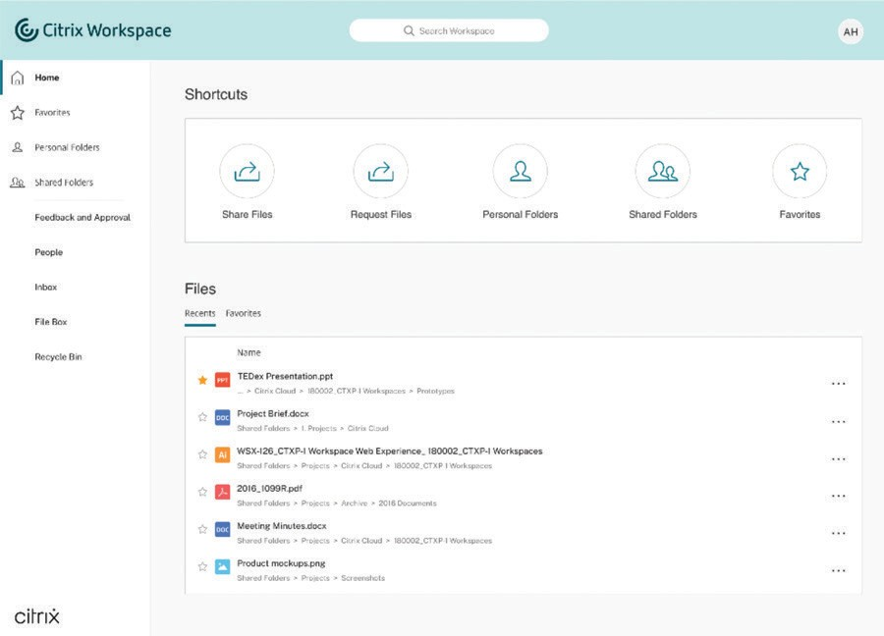Access via a mapped drive: Go to help-docs.citrix.com
/en-us/citrix-files/ to download the Citrix Files tool. Once downloaded, simply map to a drive and then save your file and it is automatically synced from the cloud to
your desktop.
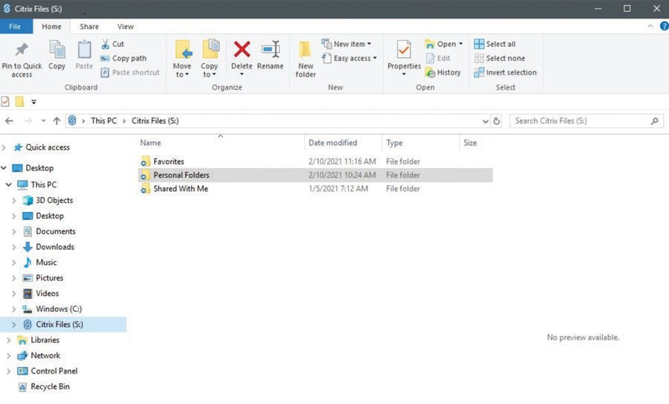

- Mobile app: If you’re accessing Content Collaboration through your mobile app, navigate to the folder where you’d like to upload the file, click the + button, select Upload, and browse to find the file you want to upload. Download mobile apps here: help-docs.citrix.com /en-us/ citrix-files/.

How do I share a file?
Files are securely shared via a link. There are several ways to generate a shared link.
- Email with Content Collaboration: This feature allows you to email your file(s) directly from Content Collaboration. With this method, the recipient receives an email message containing a secure link to download the file(s). You can send a file stored on your account, or send a file stored on your computer.
  - To email a file stored on your account: Right-click on the file in Content Collaboration, choose the Share option, then select Email with Citrix.
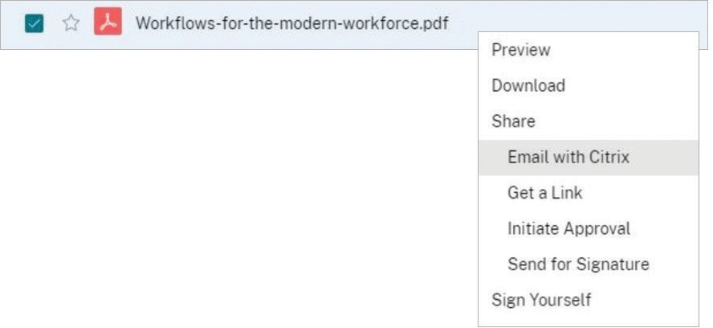

  - To email a file stored on your computer: Go to your Content Collaboration dashboard shortcuts, choose Share Files, then select Email with Citrix.

Edit file view options
Select Edit Message Options to add additional view options such as amount of downloads, date the link expires, or receive notification of when the link is accessed.
What your recipient sees:
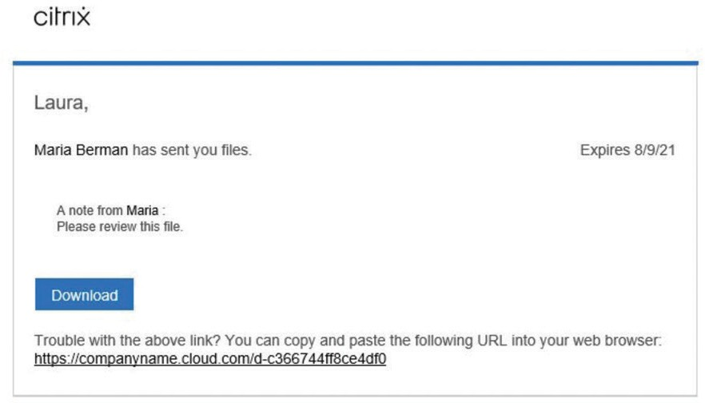

- Get a Link: This feature creates a link you can copy and paste into any email or chat message to allow a recipient to safely access your file. You can share a file stored on your account, or share a file stored on your computer.

To get a link for a file stored on your account:
Right-click on the document, and select Share and then Get a Link. Copy and paste the link and share. You can also select Share from the top of the page and select multiple files or a folder.

To get a link for a file stored on your computer:
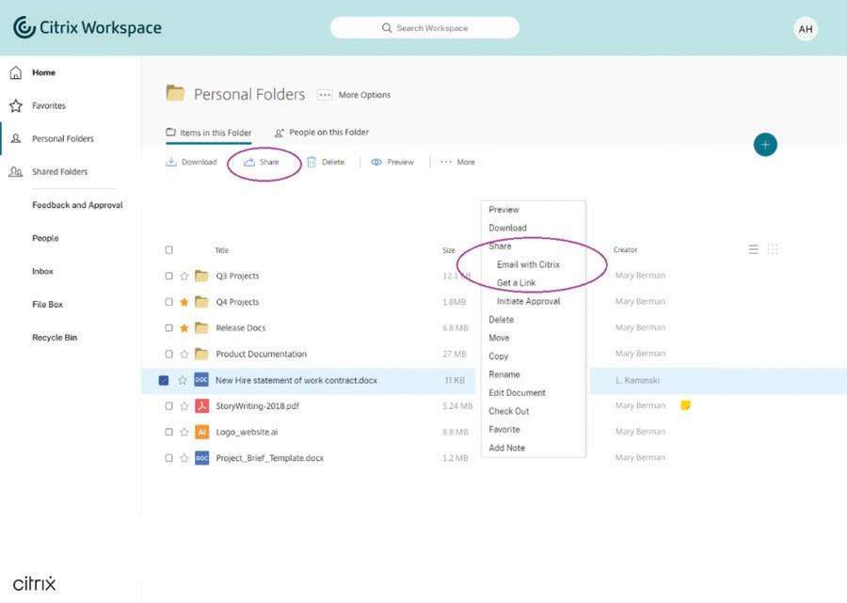Go to your Content Collaboration dashboard shortcuts on the Home tab, choose Share Files, and then select Get a Link. Copy and paste the link, and share.

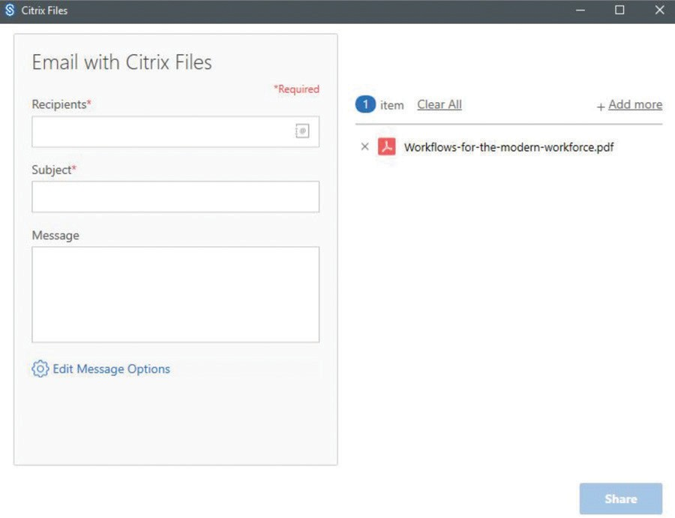

Edit file share permissions
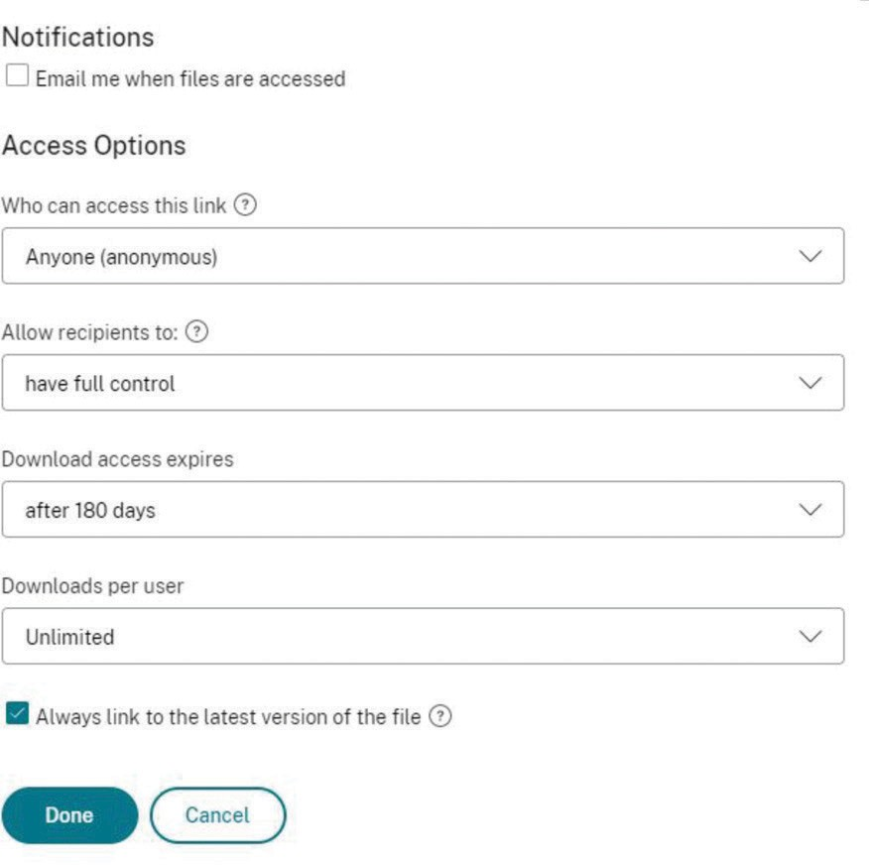Select options for how your recipient will interact with your link share.

How do I send a file through Gmail or other accounts?
The easiest way to send a file through any email program is to use the “Get a Link” function within Content Collaboration from your browser. Copy and paste the generated link from Content Collaboration into your Gmail message for a quick, safe way to share your file.

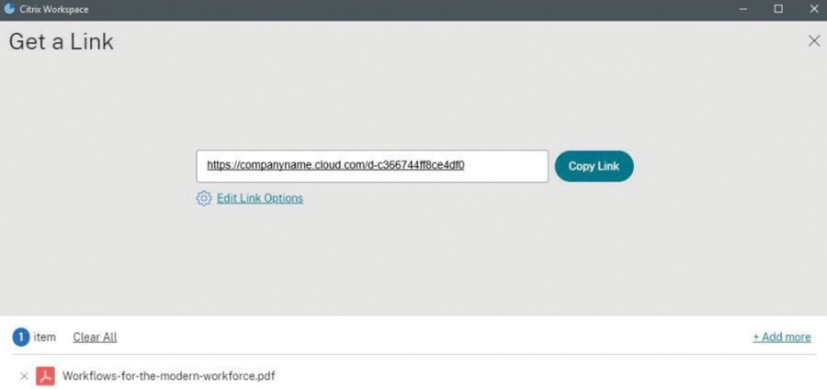

How do I send a file through Microsoft Outlook?
Once you download Citrix Files for Outlook
(help-docs.citrix.com/en-us/citrix-files/citrix-files-for- outlook/about.html), simply open a new email message, you’ll see the Citrix Files features within the Message tab. You have two options for adding a file to
your message:

    - Convert Attachments will turn any files you’ve already attached to the email into secure Content Collaboration documents.
    - Attach Files allows you to use Content Collaboration to attach documents that are either saved in your Content Collaboration account or stored locally on your computer.
See full details here: https://help-docs.citrix.com/en-us/ citrix-files/citrix-files-for-outlook/accessing.html.

How do I send an encrypted email?
When you open a new email message in Outlook, you’ll see a padlock icon on the left of the message ribbon. Click the drop-down arrow and select Use Custom Settings. After confirming a few options, your
entire message text will be encrypted—both on its way to your recipient and once it’s in their inbox.
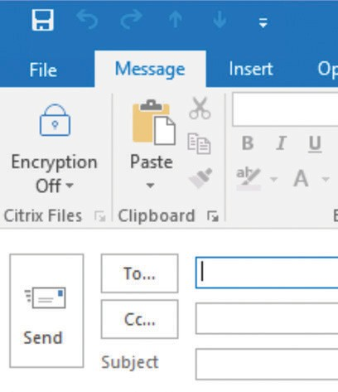

What file types can I upload?
Content Collaboration supports all file types.

How do I request a file from a coworker or client?
There are three ways to access this feature.

- Locate the Request Files icon on your account dashboard within the Home section.
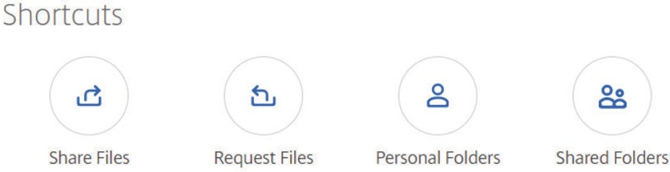

- Initiate within and new message from Microsoft Outlook. Within the Message tab, select Request Files.
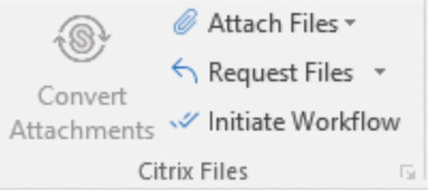

- 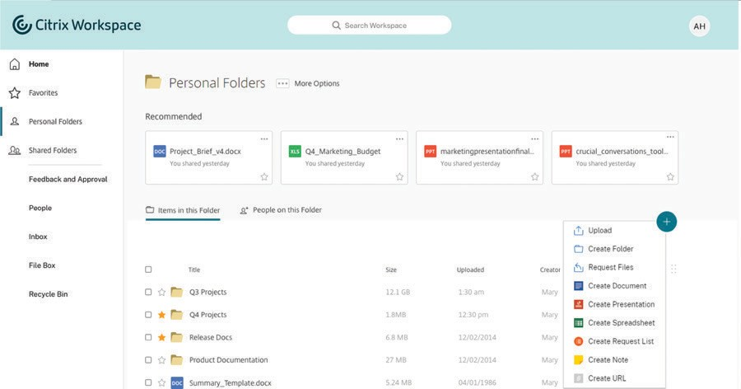Web browser: Navigate to the folder where you’d like to upload a file. Click the + ... button, select Request Files.
Next, there are two options to easily request a file from someone.
- Request with Citrix: Choose this option to send
a request through Content Collaboration. Fill out the fields for recipients and message, check the location where you’d like files uploaded, and click Send.
- Get a link: Choose this option to request a link to embed in an email, chat, or site. Verify the location where you’d like files uploaded, and click Get a Link.
A. You can place this link right in your email signature from Outlook. Open a new email, and click the Insert tab. You’ll see an icon for Signature. Open the drop- down arrow, and click Signatures... In the Edit Signature box, you can place the link wherever you’d like in your email signature. Save it, and it’s ready to send.
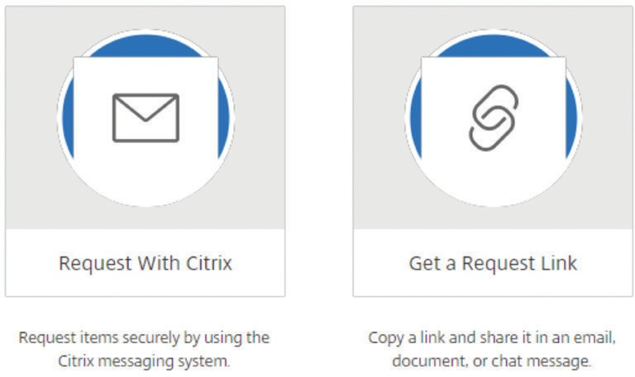

Still need help?
Here are some additional resources:

- Citrix Files

Enterprise Sales
North America | 800-424-8749 Worldwide | +1 408-790-8000
Locations
Corporate Headquarters | 851 Cypress Creek Road, Fort Lauderdale, FL 33309, United States Silicon Valley | 4988 Great America Parkway, Santa Clara, CA 95054, United States
©2021 Citrix Systems, Inc. All rights reserved. Citrix, the Citrix logo, and other marks appearing herein are property of Citrix Systems, Inc. and/or one or more of its subsidiaries, and may be registered with the U.S. Patent and Trademark Office and in other countries. All other marks are the property of their respective owner(s).

