Getting Started Guide

Welcome to a better way to work

Getting started with Citrix Workspace for PC
Your new workspace is the easiest way to get work done across all your devices, from wherever you are. To get started, simply download Citrix Workspace app for instant, secure access to all your apps, desktops, and files.

What’s inside
How to install Citrix Workspace app How to access your apps
How to access your desktops How to access your files
How to access your workspace on your mobile device
3

5

5

6

7

How to install Citrix Workspace app

Step 1
Navigate to www.citrix.com/downloads/workspace-app/
on your web browser.

Step 2
Click Download Citrix Workspace app for Windows. The Citrix Workspace app executable file is downloaded.

Step 3
Double click the CitrixWorkspaceApp.exe file to start the installation.

Step 4
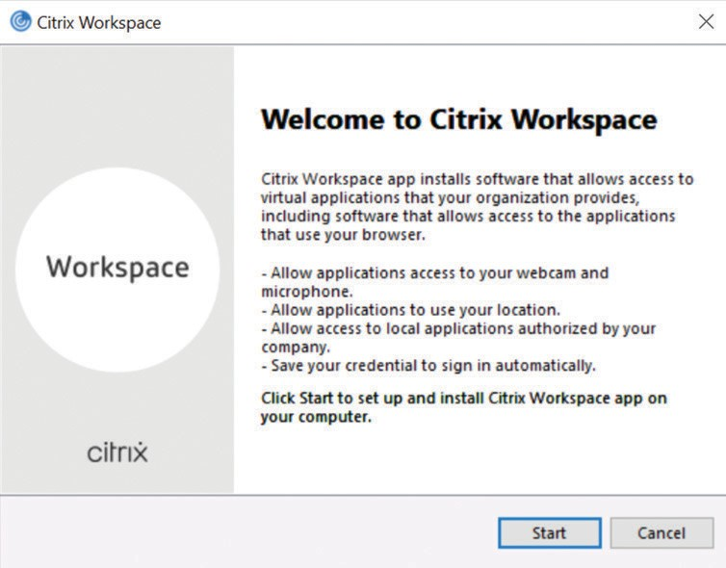Click Start on the Installation screen to the installation.

Step 6
If you want to enable single sign-on, select Enable single sign-on. For more information about single sign-on, see Domain pass-through authentication section in the product documentation.
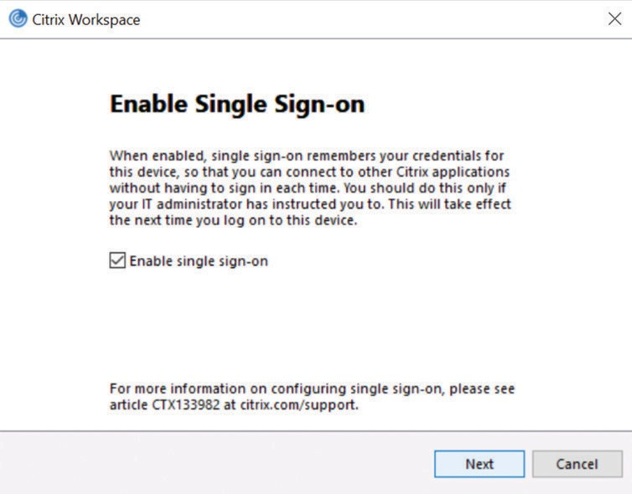

Step 7
If you want to enable app protection, select Enable app protection. For more information on app protection, see App protection section in product documentation.

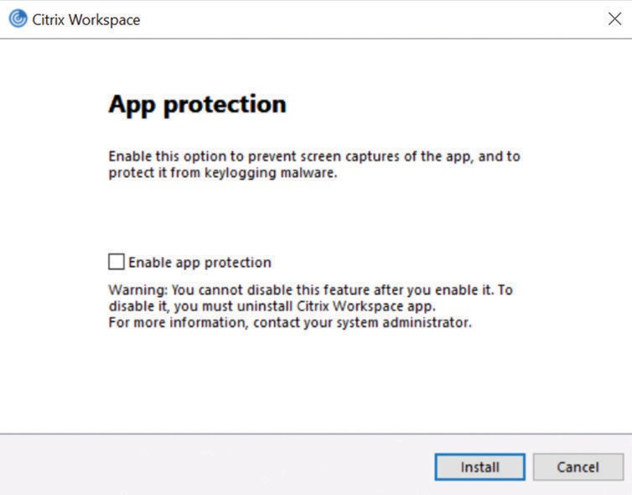Step 5
Accept the license agreement and click Next.
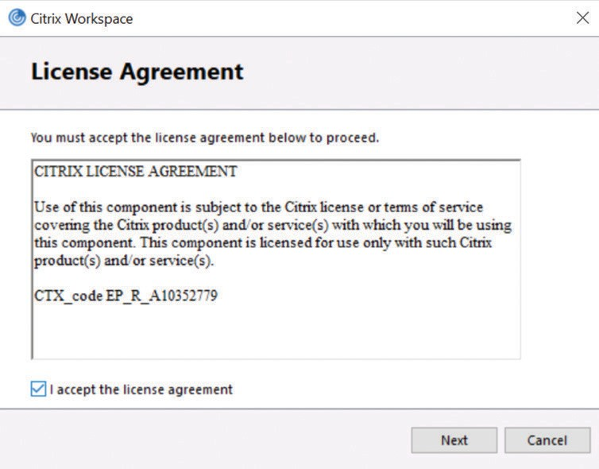

Step 8
Follow the installation prompts to complete the installation.

Step 9
Once the installation is complete, click Add Account
to add an account.

Step 11
After you add the account, a prompt appears asking you to enter your credentials. Enter your username and password and click Sign in.

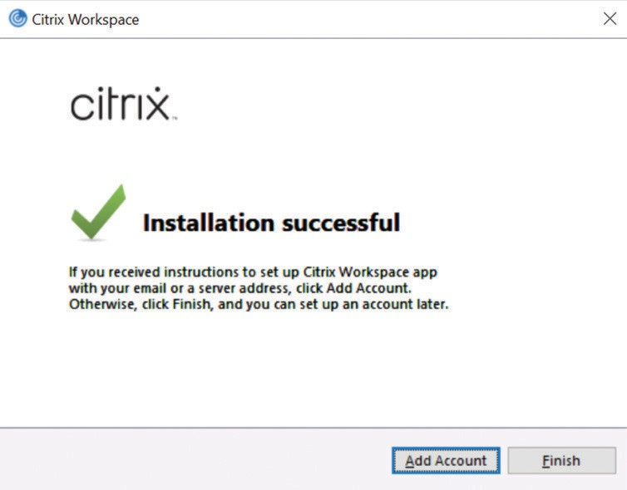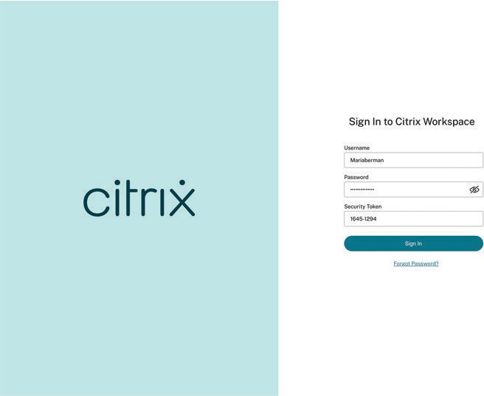Citrix Workspace app is launched with published apps and desktops.

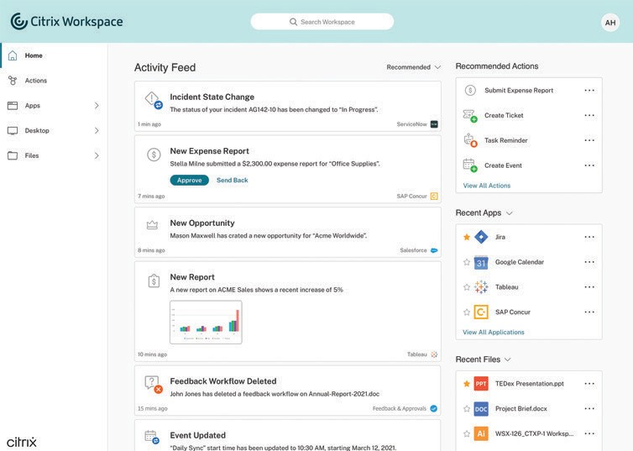Step 10
Enter your workspace URL as provided by your organization and click Add.
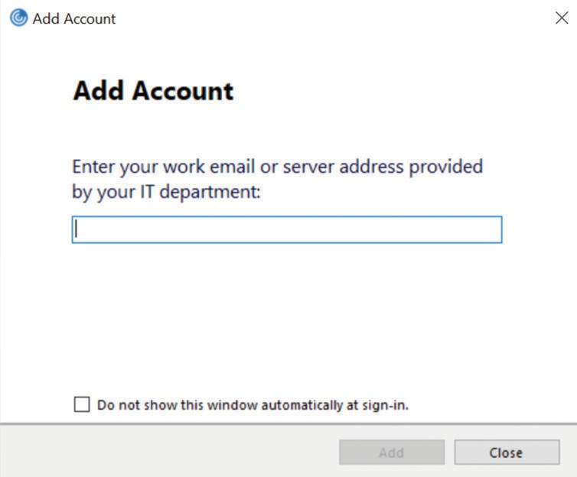

How to access your apps

Step 1
From the Home screen, click on the Apps tab on the left navigation bar. From there, you can choose All Apps or Favorites.

Step 2
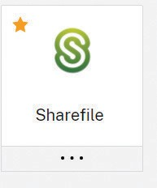To “Favorite” an app, select the star. Then, click on the application card to open it an access the app.

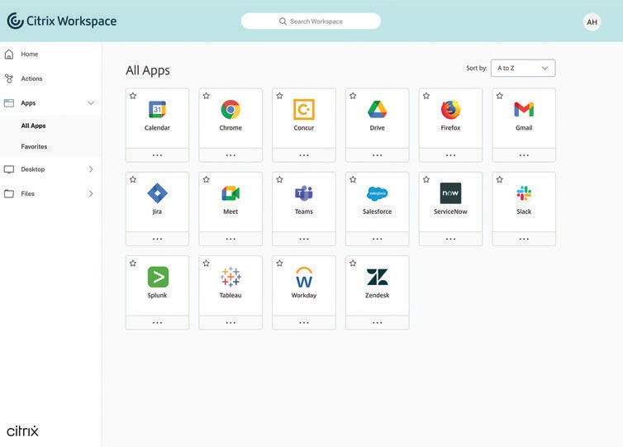

How to access your desktops

Step 1
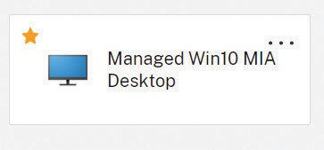From the Home screen, click on the Desktops tab on the left navigation bar. From there, you can choose All Desktops or Favorites.

Step 2
To “Favorite” a desktop, select the star. Then, click
on the desktop card to open it an access the desktop.

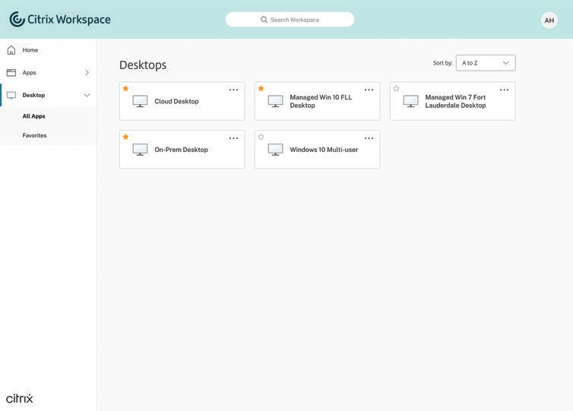

How to access your files

Step 1
From the Home screen, click on the Files tab on the left navigation bar. From there, you will have access to all your files, no matter where they are stored.

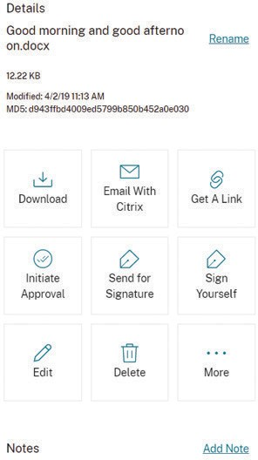Step 2

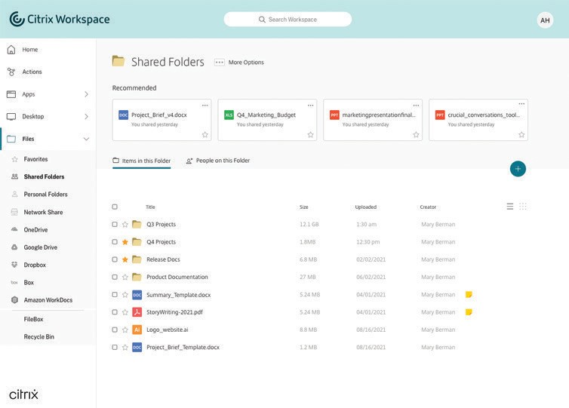When you access a file, you’ll be able to perform the following actions:
- Download
- Email
- Get a link
- Initiate approval
- Delete
- Copy
- Move
- Add notes

How to access your workspace on your mobile device

Step 1
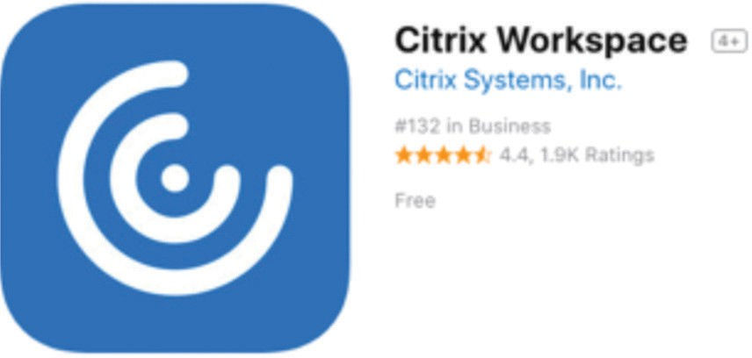
To download Citrix Workspace app on your mobile device, visit the App Store or Google Play, search for “Citrix Workspace app.” Once you download the app, sign in with your corporate credentials.

Step 2
Step 3
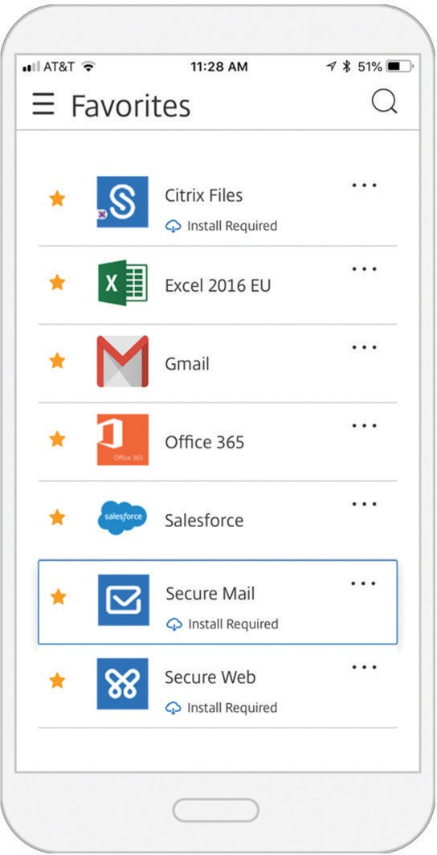
On your mobile device, you have access to secure productivity apps, like Secure Mail. For more on how to use Secure Mail, read the user guides.

Enterprise Sales
North America | 800-424-8749 Worldwide | +1 408-790-8000
Locations
Corporate Headquarters | 851 Cypress Creek Road, Fort Lauderdale, FL 33309, United States Silicon Valley | 4988 Great America Parkway, Santa Clara, CA 95054, United States
©2021 Citrix Systems, Inc. All rights reserved. Citrix, the Citrix logo, and other marks appearing herein are property of Citrix Systems, Inc. and/or one or more of its subsidiaries, and may be registered with the U.S. Patent and Trademark Office and in other countries. All other marks are the property of their respective owner(s).

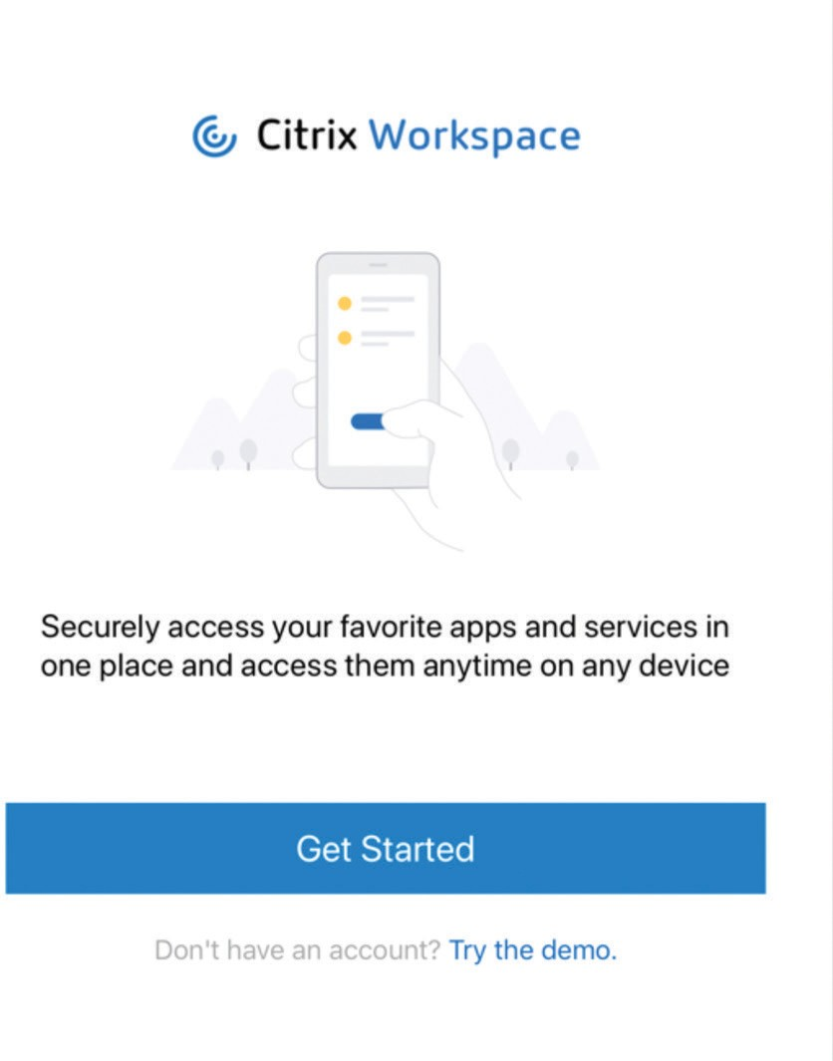Citrix Workspace app will prompt you to then download
Citrix Secure Hub for authentication purposes.

