Citrix Virtual Apps and Desktops User Guide
Welcome to the simple, secure way to connect on any device, anywhere.

User Guide

Citrix | Citrix Virtual Apps and Desktops User Guide
2
Contents

Welcome 3
Before you start 3
Installing Citrix Workspace app (full version) 3
Launching apps and desktops 6
Saving files to shared or network folder 6
Using the light version of Citrix Workspace app 7

Welcome
This guide shows you how to use Citrix Workspace app to connect to your apps and desktops—without compromising quality or speed. Now, whether you’re working in the office, from home or while traveling, you can get work done from any device, anytime.

Before you start
Get your credentials
Make sure you have your user name and password from your system administrator.

Example:
Username: [LindaHam]
Password: [Terminator2]

The address of your Workspace for Citrix Virtual Apps and Desktops and your Citrix Workspace app is: [https://companyX.cloud.com]

Now you’re ready to use Citrix Workspace app to access your apps and desktops.

Installing Citrix Workspace app (full version)
- Open your web browser and navigate to https://www.citrix.com/downloads/workspace-app/ windows/workspace-app-for-windows-latest.html.
- Click on Download Citrix Workspace App for Windows.
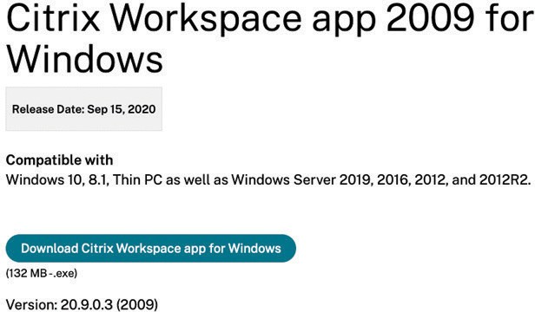

- Right-click the Citrix Workspace App executable and select Run as Administrator.
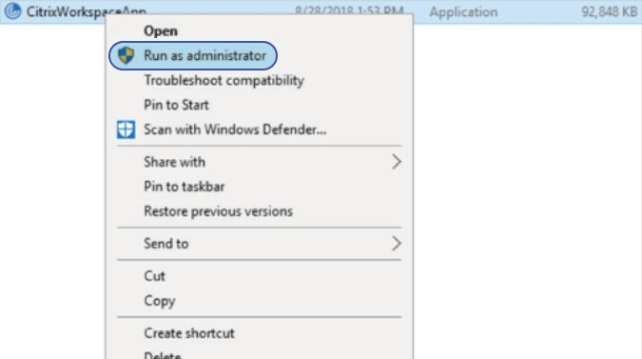

- On the Welcome to Citrix Workspace window, click Start.
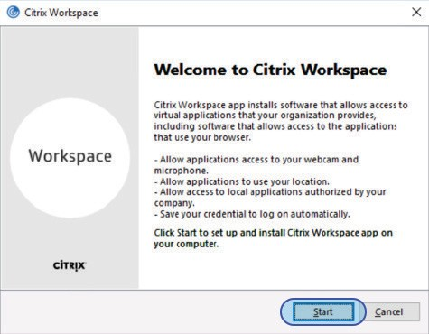

- On the License Agreement screen, check the box next to I accept the license agreement and click Install.
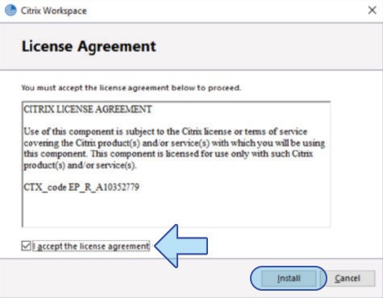

- On the Installation Successful window, click Add Account.
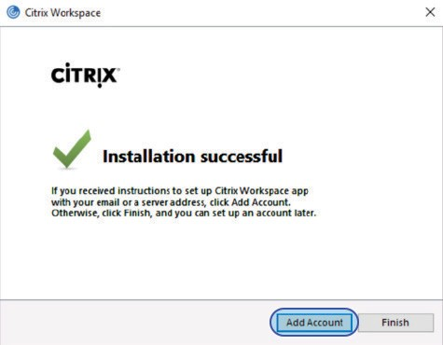

- On the Add Account window, enter your Workspace URL and click Add.
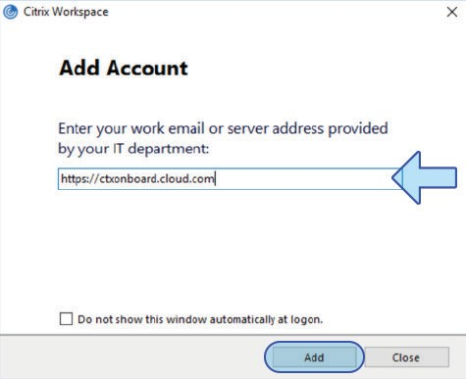

- On the Log On screen, enter your User Name and Password, and click Log On.
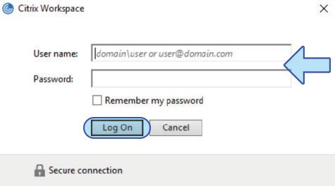

Launching apps and desktops
Enter your credentials to sign in.
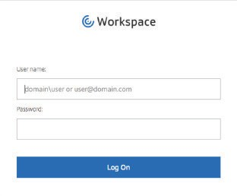

Apps Tab: This is where you will access all of the apps your administrator has installed. If you click on the arrow, you will see the app description. To launch, simply click on the icon.
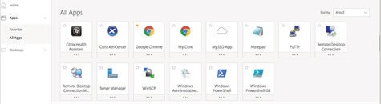

Desktop tab: This is where you will access the virtual desktops your administrator has configured. If you click on the arrow, you will see the desktop description. To launch, simply click on the icon.
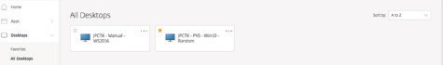

Saving files to a shared or network folder
To save a file you are working on in a launched app or desktop, go to the File menu, click Save or
Save as. Then select This PC, and choose the folder where you want to save your file.
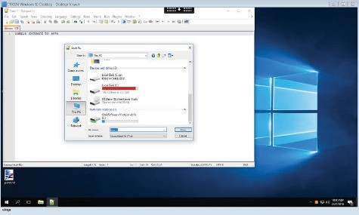

Enterprise Sales
North America | 800-424-8749 Worldwide | +1 408-790-8000
Locations
Corporate Headquarters | 851 Cypress Creek Road, Fort Lauderdale, FL 33309, United States Silicon Valley | 4988 Great America Parkway, Santa Clara, CA 95054, United States
©2020 Citrix Systems, Inc. All rights reserved. Citrix, the Citrix logo, and other marks appearing herein are property of Citrix Systems, Inc. and/or one or more of its subsidiaries, and may be registered with the U.S. Patent and Trademark Office and in other countries. All other marks are the property of their respective owner(s).

Using the light version of Citrix Workspace
You can use the light version of Citrix Workspace app if you’re not using your work computer or don’t want to download the Citrix Workspace app software on the computer or device you’re using. The light version opens the apps in your browser.
To use the light version:

- Go to https://companyX.cloud.com [enter your company URL here].

- Under Account Settings > Apps and Desktops Launch Preference, click on Use Web Browser.
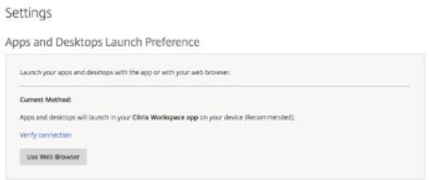

- Click Use web browser.
