Citrix Files for Windows and Citrix Files for Mac

Citrix Files for Windows and Citrix Files for Mac
Deliver secure access to all your files

4 reasons to start using Citrix Files for Windows and Citrix Files for Mac today

- Quick access to all your files: Connect a ShareFile account as a mapped drive without performing a full sync of content.
- Flexibility: A single point of access to multiple data repositories.

- Tools at your fingertips: Simply right-click to manage folder permissions, add items to favorites, initiate workflows, and view item details, like notes and file versions. Also see recent activity in the menu bar.
- More control: Set notifications when someone uploads, downloads, renames, or checks out files.
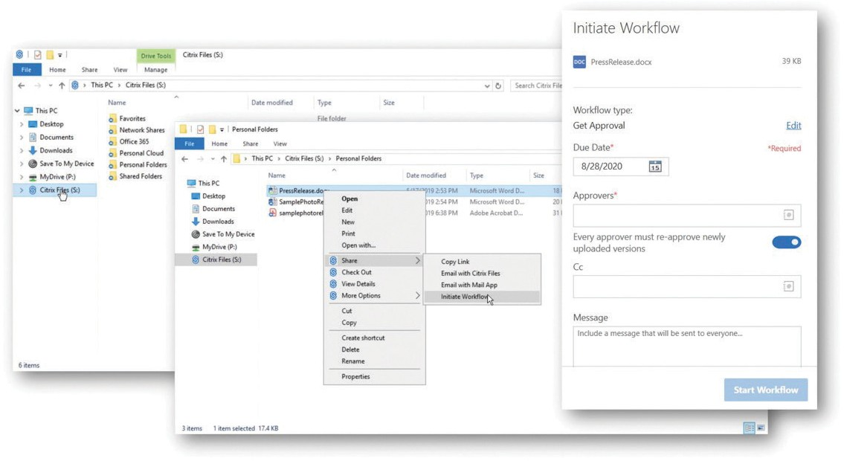

©2021 Citrix Systems, Inc. All rights reserved. Citrix, the Citrix logo, and other marks appearing herein are property of Citrix Systems, Inc. and/or one or more of its subsidiaries, and may be registered with the U.S. Patent and Trademark Office and in other countries. All other marks are the property of their respective owner(s).

